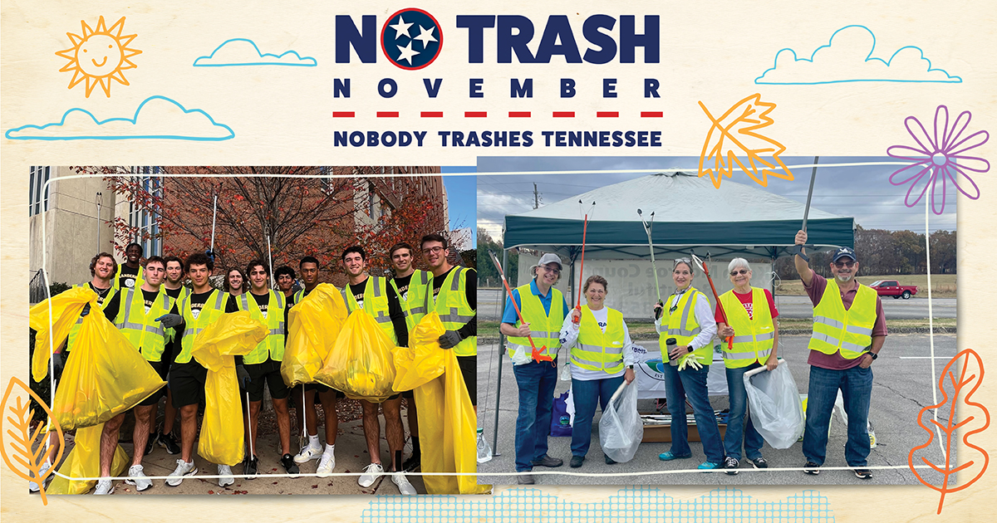

**ORG NAME hosts litter cleanup on DATE as part of the 4th Annual No Trash November**

**CITY, Tenn. – DATE, 2024 –** ORG NAMEis partnering with [Tennessee Department of Transportation](https://www.tn.gov/tdot.html)’s (TDOT) [Nobody Trashes Tennessee](https://nobodytrashestennessee.com/) in their [No Trash November](https://nobodytrashestennessee.com/no-trash-november/) campaign, a month-long statewide initiative encouraging Tennesseans to participate in cleanup events in their communities. Last year’s campaign included more than 150 events with over 2,200 volunteers who collected more than 86,000 pounds of litter from the state’s roadways.

Spearheaded by TDOT’s Nobody Trashes Tennessee campaign, the initiative brings together [Keep Tennessee Beautiful](https://www.keeptnbeautiful.org/) affiliates, TDOT Grantees, [Adopt-A-Highway](https://nobodytrashestennessee.com/adopt-a-highway/) groups, [Girl Scouts, Boy Scouts](https://nobodytrashestennessee.com/talking-trash-litter-worksheets/), and individuals that are working together to end littering.

ORG NAME’s community cleanup will be held on DATE/TIME at LOCATION. “INSERT QUOTE,” said NAME, TITLE, ORG. “CONT. QUOTE.” OPTIONAL - INSERT 2-3 SENTENCES ABOUT ORG’S PAST/CURRENT EFFORTS.

All safety gear and cleanup supplies will be provided by ORG. Residents interested in participating in the cleanup may contact INSERT.

“We are grateful for our many partners across the state that are once again coming together in November to help us in our mission to prevent and reduce litter” said Morris. “By working together to improve and beautify communities across the state, we can make an even larger impact as we strive to prevent and reduce roadside litter in Tennessee.”

New this year, and to encourage individuals to get involved in No Trash November, is the [Trash Masters Rewards](https://nobodytrashestennessee.com/trash-masters/) program. Participants earn points for various activities like taking a litter quiz, attending cleanup events, and spreading awareness. Participants can earn double points for all activities throughout the month of November, making it the perfect time to join. Points can be redeemed for a variety of rewards, including discounts at local businesses and exclusive NTT swag. It's a fun and engaging way for individuals to contribute to a litter-free Tennessee while being recognized for their commitment to the environment.

To find a local cleanup event and to register your group to participate in No Trash November, visit [nobodytrashestennessee.com/events](https://nobodytrashestennessee.com/events). Campaign tools and resources including a cleanup location map and a trash tracker measuring pounds collected are also available online.

All residents are encouraged to show their support for a litter-free Tennessee by using the #NobodyTrashesTennessee and #NoTrashNovember hashtags in social media and to highlight their litter prevention actions throughout the month. For additional ways to participate in No Trash November, visit: [5 Ways to Participate in No Trash November](https://nobodytrashestennessee.com/you-can-participate-in-no-trash-november-in-5-easy-steps/).

**About INSERT ORG**

INSERT Boilerplate

**About Nobody Trashes Tennessee**

Nobody Trashes Tennessee (NTT) is the State of Tennessee’s official litter prevention campaign managed by [Tennessee Department of Transportation](https://www.tn.gov/) (TDOT). Visit [nobodytrashestennessee.com](https://nobodytrashestennessee.com/) to learn more about TDOT’s Adopt-A-Highway program and additional ways to get involved in helping to prevent and reduce litter through personal actions, community events, and reporting littering incidents through the [Tennessee Litter Hotline](https://nobodytrashestennessee.com/litter-hotline/) (1-877-8LITTER). Be rewarded for taking action to reduce litter through the [Trash Masters Rewards](https://nobodytrashestennessee.com/trash-masters-early-signup/) program, and join the conversation on Facebook at [nobodytrashesTN](https://www.facebook.com/nobodytrashesTN), [instagram.com/nobodytrashestn](https://www.instagram.com/nobodytrashestn) and on X at [NobodyTrashesTN](https://twitter.com/NobodyTrashesTN).

###