MEDIA ADVISORY
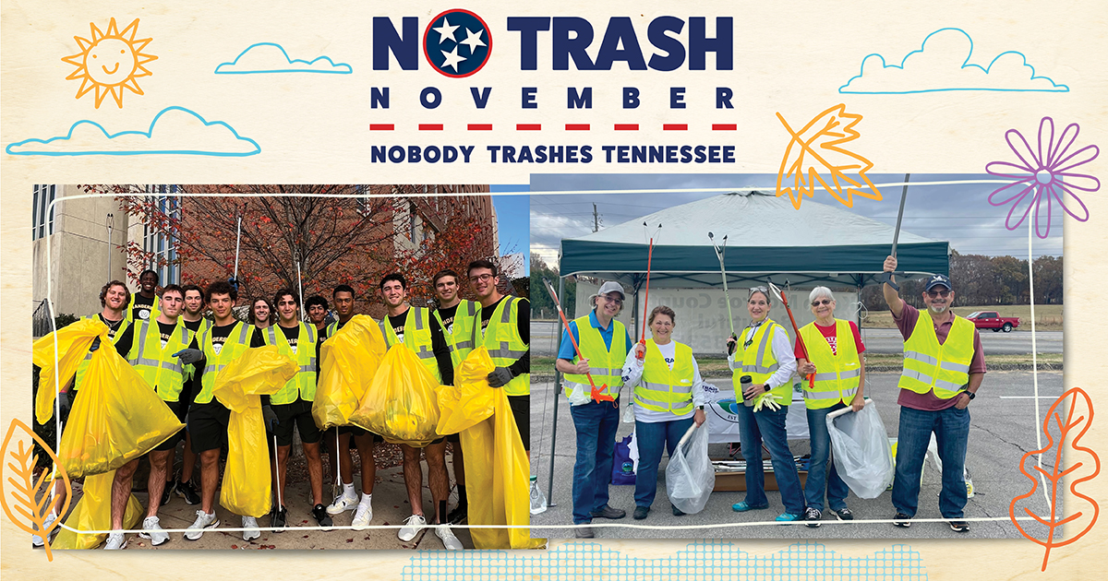
ORG NAME hosts litter cleanup on DATE as part of the 4th Annual No Trash November

CITY, Tenn. – DATE, 2024 – ORG NAME is partnering with Tennessee Department of Transportation’s (TDOT) Nobody Trashes Tennessee in their No Trash November campaign, a month-long statewide initiative encouraging Tennesseans to participate in cleanup events in their communities. Last year’s campaign included more than 150 events with over 2,200 volunteers who collected more than 86,000 pounds of litter from the state’s roadways.

Spearheaded by TDOT’s Nobody Trashes Tennessee campaign, the initiative brings together Keep Tennessee Beautiful affiliates, TDOT Grantees, Adopt-A-Highway groups, Girl Scouts, Boy Scouts, and individuals that are working together to end littering.

ORG NAME’s community cleanup will be held on DATE/TIME at LOCATION. “INSERT QUOTE,” said NAME, TITLE, ORG. “CONT. QUOTE.”

All safety gear and cleanup supplies will be provided by ORG. Residents interested in participating in the cleanup may contact INSERT.

DATE + TIME: INSERT
LOCATION: INSERT
WHO: ORG Name, OTHER PARTNERS
CONTACT: INSERT ORG CONTACT NAME, EMAIL, CELL PHONE NUMBER

About INSERT ORG
INSERT Boilerplate

About Nobody Trashes Tennessee
Nobody Trashes Tennessee (NTT) is the State of Tennessee’s official litter prevention campaign managed by Tennessee Department of Transportation (TDOT). Visit nobodytrashestennessee.com to learn more about TDOT’s Adopt-A-Highway program and additional ways to get involved in helping to prevent and reduce litter through personal actions, community events, and reporting littering incidents through the Tennessee Litter Hotline (1-877-8LITTER). Be rewarded for taking action to reduce litter through the Trash Masters Rewards program, and join the conversation on Facebook at nobodytrashesTN, instagram.com/nobodytrashestn and on X at NobodyTrashesTN.

###

###

