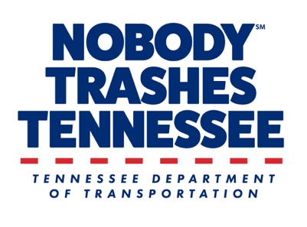

INSERT ORG LOGO/PARTNERS LOGOS

MEDIA ADVISORY

ORG NAME hosts litter cleanup on DATE as part of CAMPAIGN/OBSERVANCE
(INSERT call to action/volunteers needed/pounds of litter collected goal)

(INSERT IMAGE from past cleanup if available, label with brief description)

CITY, Tenn. – DATE, YEAR – ORG NAME is hosting a litter cleanup in observance of (Great American Cleanup/Earth Day/No Trash November/OTHER). INSERT 2-3 sentences about the importance of cleanup/impact to the community.

In partnership with INSERT PARTNERS and Tennessee Department of Transportation’s (TDOT) Nobody Trashes Tennessee, the public is invited to participate in the cleanup and may sign up at INSERT HOW TO SIGN UP. All safety gear and cleanup supplies will be provided by ORG.

DATE + TIME: INSERT

LOCATION: INSERT

WHO: ORG Name, OTHER PARTNERS

CONTACT: INSERT ORG CONTACT NAME, EMAIL, CELL PHONE NUMBER

About ORG
INSERT BOILERPLATE

About Nobody Trashes Tennessee
Nobody Trashes Tennessee (NTT) is the State of Tennessee’s official litter prevention campaign managed by Tennessee Department of Transportation (TDOT). Visit nobodytrashestennessee.com to learn more about TDOT’s Adopt-A-Highway program and additional ways to get involved in helping to prevent and reduce litter through personal actions, community events, and reporting littering incidents through the Tennessee Litter Hotline (1-877-8LITTER). Join the conversation at facebook.com/nobodytrashesTN, instagram.com/nobodytrashestn and twitter.com/NobodyTrashesTN.

###

